Nobody

Doubly LINKED LIST

Experiment No.:2b

08/08/2012

# AIM:

# Implement Singly Linked List.

# ALGORITHM:

All the linked list algorithms here uses a linked list with nodes with structure as following:

|  |  |  |
| --- | --- | --- |
| Prev | Data | Next |

The members of the structure node are:

Prev: Holds the link to the previous node

Data: Holds the data for the current node.

Next: Holds the link to the next node.

Here a linked list is represented as a structure as following:

|  |  |
| --- | --- |
| Head | Length |

Head: Head node of the linked list.

Length: Current number of nodes of the linked list initialized at 0.

The function ins() inserts a node at a specific index of a given singly linked list.

Arguments passed:

list: A linked list .

data: The data to be inserted in list.

index: The index where the data is to be inserted in the linked list.

Return value: none.

ins(list, data, index)

{

temp=createnode() /* The function createnode() is used to allocate a space or a * node in memory */

/* 'temp', a pointer to node, is used to hold the newly created * node */

temp⇾data=data

temp1=list⇾head /* 'temp1',a pointer to node, is used to access the list * sequentially */

i=0 /* 'i' is used to count the index of the node 'temp1' is currently * holding */

while(i<index)

{

temp1=temp1⇾next

i=i+1

}

temp⇾next=temp1

temp⇾prev=temp1⇾prev

temp1=temp

list⇾length=list⇾length+1

}

The function del() deletes a node at a specific index from a given singly linked list.

Arguments passed:

list: A linkedlist.

index: The index of the node to be deleted in the linked list.

Return value: Returns the deleted data on success and 0 on failure.

del(list, index)

{

temp1=list⇾head /* 'temp1',a pointer to node is used to access the * linked list sequentially */

i=1 /* 'i' is used to count the index of the node 'temp1' is current;y * holding */

while(i<index)

{

temp1=temp1⇾next

i=i+1

}

temp=temp1 /* 'temp', a pointer to mode, holds the node to be deleted */

temp1=temp1⇾next

temp1⇾prev=temp⇾prev

buf=temp⇾data /* 'buf' holds the data to be returned */

freenode(temp) /* the function freenode() deallocates an allocated space of a * node in memory */

list⇾length=list⇾length-1

return buf

}

The function linear_search() searches indices all nodes mathing with a given data in a singly linked list using the linear search method.

Arguments passed:

list: A limked list.

data: The data to be searched in the linked list.

Return value: Returns 1 on success and 0 on failure.

linear_search(list, data)

{

found=0 /* 'found' is a flag, indicates whether the data is found */

temp=list⇾head /* 'temp' is a pointer to node, used to access the linked list * sequentially */

i=1 /* 'i' counts the index if the node hold by 'temp' */

while(temp ≠ NULL)

{

if(temp⇾data=data)

{

found=1;

print “Data found at position i”

}

temp=temp⇾next

i=i+1

}

if(found=0)

print "Data not found"

return found

}

The function display() prints a singly linked list from a given lower bound to a given upper bound of index.

Arguments passed:

list: A linked list.

lb: Lower bound of the index to printed.

ub: Upper bound of the index to printed.

Return value: None.

display(list, lb, ub)

{

i=1;

temp=list⇾head

while(i ≤ ub AND temp ≠ NULL)

{

if(i ≥ lb)

{

print "temp⇾data”

}

temp=temp⇾next

i=i+1

}

}

# SOURCE CODE:

#include <iostream>

#include <cstdlib>

#include <cstdio>

#include <vector>

#include "../myexception.h"

using namespace std;

using namespace exception;

template<class DT> class Node {

public:

DT data;

Node *next, *prev;

Node(DT, Node*, Node*);

};

template<class DT> Node<DT>::Node(DT data, Node* next=NULL, Node* prev=NULL) {

Node<DT>::data=data;

Node<DT>::next=next;

Node<DT>::prev=prev;

}

template<class DT> class LinkedList {

int length;

Node<DT> **head;

public:

LinkedList(int);

LinkedList(const LinkedList<DT>&);

~LinkedList();

int getLength();

void insert(int, DT);

DT remove(int);

DT& operator[](int);

DT get(int);

void set(int, DT);

void clear();

void traverse();

vector<int> search(DT);

};

template<class DT> LinkedList<DT>::LinkedList(int size=0) {

try{

LinkedList::head=new Node<DT>*;

*(LinkedList::head)=NULL;

for(int i=0;i<size; i++) {

Node<DT> *temp=*(LinkedList::head);

*(LinkedList::head)=new Node<DT>((DT)0, temp);

LinkedList::length=0;

}

} catch(bad_alloc) {

cerr<<"ERROR : bad_alloc"<<endl;

}

}

template<class DT> LinkedList<DT>::LinkedList(const LinkedList<DT>& l) {

try{

LinkedList::head=new Node<DT>*;

*(LinkedList::head)=NULL;

for(Node<DT> *temp1=*(l.head), **temp2=LinkedList::head; temp1!=NULL; temp1=temp1->next, temp2=&((*temp2)->next))

*temp2=new Node<DT>(temp1->data);

LinkedList::length=l.length;

} catch(bad_alloc) {

cerr<<"ERROR : bad_alloc"<<endl;

}

}

template<class DT> LinkedList<DT>::~LinkedList() {

for(Node<DT> **temp=LinkedList::head; *temp!=NULL;) {

Node<DT> *delnode=*temp;

*temp=(*temp)->next;

delete delnode;

}

LinkedList::length=0;

delete LinkedList::head;

}

template<class DT> int LinkedList<DT>::getLength() {

return LinkedList::length;

}

template<class DT> void LinkedList<DT>::insert(int index, DT data) {

if(index<0 || index>LinkedList::length)

throw IndexOutOfBoundsException();

Node<DT> **temp=LinkedList::head;

for(int i=0; *temp!=NULL && i<index; temp=&((*temp)->next), i++);

try{

Node<DT>* newnode=new Node<DT>(data, *temp, (*temp)->prev);

*temp=newnode;

LinkedList::length++;

} catch(bad_alloc ex) {

cerr<<"ERROR : bad_alloc"<<endl;

}

}

template<class DT> DT LinkedList<DT>::remove(int index) {

if(LinkedList::length==0)

throw LinkedListEmptyException();

if(index<0 || index>=LinkedList::length)

throw IndexOutOfBoundsException();

Node<DT> **temp=LinkedList::head;

for(int i=0; *temp!=NULL && i<index; temp=&((*temp)->next), i++);

Node<DT> *delnode=*temp;

*temp=(*temp)->next;

(*temp)->prev=delnode->prev;

DT data=delnode->data;

delete delnode;

LinkedList::length--;

return data;

}

template<class DT> DT& LinkedList<DT>::operator[](int index) {

if(LinkedList::length==0)

throw LinkedListEmptyException();

if(index<0 || index>=LinkedList::length)

throw IndexOutOfBoundsException();

Node<DT> *temp=*LinkedList::head;

for(int i=0; temp!=NULL && i<index; temp=temp->next, i++);

return temp->data;

}

template<class DT> DT LinkedList<DT>::get(int index) {

if(LinkedList::length==0)

throw LinkedListEmptyException();

if(index<0 || index>=LinkedList::length)

throw IndexOutOfBoundsException();

Node<DT> *temp=*LinkedList::head;

for(int i=0; temp!=NULL && i<index; temp=temp->next, i++);

return temp->data;

}

template<class DT> void LinkedList<DT>::set(int index, DT data) {

if(LinkedList::length==0)

throw LinkedListEmptyException();

if(index<0 || index>=LinkedList::length)

throw IndexOutOfBoundsException();

Node<DT> *temp=*LinkedList::head;

for(int i=0; temp!=NULL && i<index; temp=temp->next, i++);

temp->data=data;

}

template<class DT> void LinkedList<DT>::clear() {

if(LinkedList::length==0)

throw LinkedListEmptyException();

for(Node<DT> **temp=LinkedList::head; *temp!=NULL;) {

Node<DT> *delnode=*temp;

*temp=(*temp)->next;

delete delnode;

}

LinkedList::length=0;

}

template<class DT> void LinkedList<DT>::traverse() {

for(int i=0; i<getLength(); i++)

cout<<i<<" -> "<<get(i)<<endl;

}

template<class DT> ostream& operator<<(ostream& os, LinkedList<DT> l) {

os<<"{";

for(int i=0; i<l.getLength(); i++)

os<<(i==0?"":",")<<l[i];

os<<"}";

return os;

}

template<class DT> vector<int> LinkedList<DT>::search(DT e) {

vector<int> result;

Node<DT> **temp=LinkedList::head;

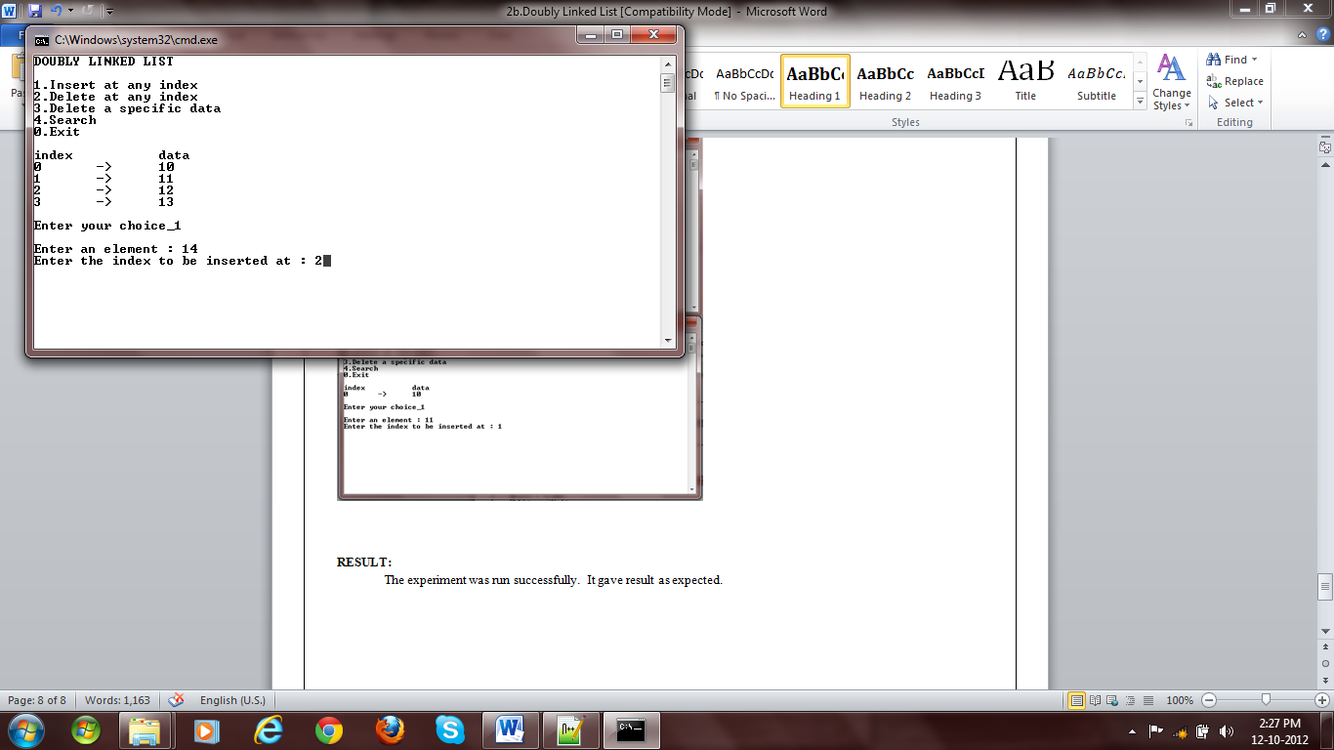

Fig 1: Insertion

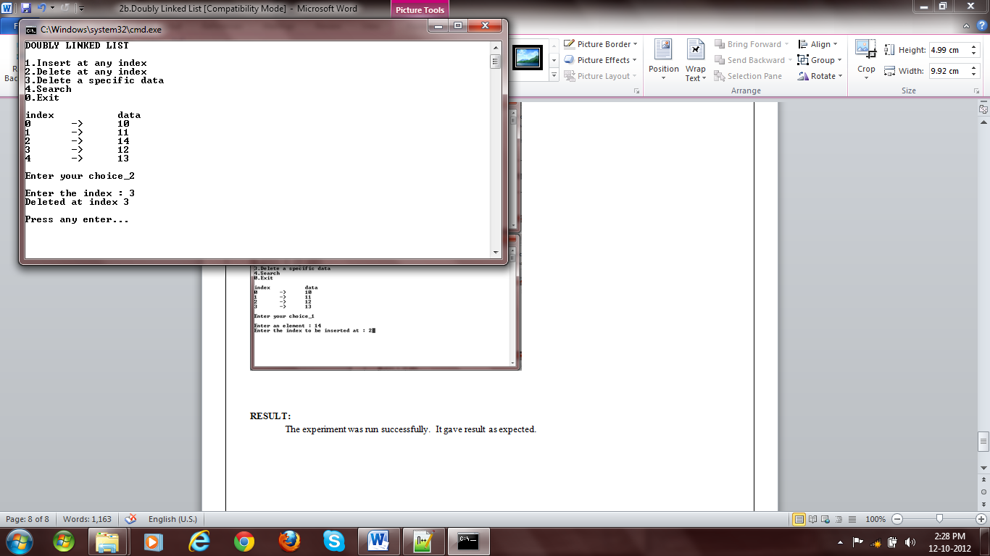

Fig 2: Deletion

for(int i=0; *temp!=NULL; temp=&((*temp)->next), i++)

if((*temp)->data==e)

result.push_back(i);

return result;

}

main() {

LinkedList<int> l(5);

int choice=1, e, idx;

vector<int> search_result;

while(choice) {

system("cls");

cout<<"DOUBLY LINKED LIST"<<endl

<<endl

<<"1.Insert at any index"<<endl

<<"2.Delete at any index"<<endl

<<"3.Delete a specific data"<<endl

<<"4.Search"<<endl

<<"5.Display"<<endl

<<"0.Exit"<<endl

<<"Enter your choice_";

cin>>choice;

cout<<endl;

switch(choice) {

case 0:

break;

case 1:

cout<<"Enter an element : ";

cin>>e;

cout<<"Enter the index to be inserted at : ";

cin>>idx;

try {

l.insert(idx, e);

}catch(IndexOutOfBoundsException ex) {

cout<<"Error : "<<ex.getMessage()<<endl;

}

break;

case 2:

cout<<"Enter the index : ";

cin>>idx;

try {

l.remove(idx);

cout<<"Deleted at index "<<idx<<endl;

}catch(IndexOutOfBoundsException ex) {

cout<<"Error : "<<ex.getMessage()<<endl;

}catch(LinkedListEmptyException ex) {

cout<<"Error : "<<ex.getMessage()<<endl;

}

break;

case 3:

cout<<"Enter an element : ";

cin>>e;

search_result=l.search(e);

if(search_result.empty())

cout<<"Not found"<<endl;

# 

Fig 3: Insertion

# 

Fig 4: Insertion

else if(search_result.size()==1) {

l.remove(search_result[0]);

cout<<"Deleted at index "<<search_result[0]<<endl;

}

else {

cout<<"Match found at index ";

for(int i=0; i<search_result.size(); i++)

cout<<search_result[i]<<",";

cout<<endl;

cout<<"Do you want to remove all occurance (y=1/n=0) : "<<endl;

cin>>choice;

switch(choice) {

case 1:

for(int i=0; i<search_result.size(); i++)

l.remove(search_result[i]-i);

break;

case 0:

cout<<"Enter index : ";

cin>>idx;

if(l[idx]==e)

l.remove(idx);

else

cout<<"Wrong index"<<endl;

break;

}

choice=3;

}

break;

case 4:

cout<<"Enter an element : ";

cin>>e;

search_result=l.search(e);

if(search_result.empty())

cout<<"Not found"<<endl;

else {

cout<<"Match found at index ";

for(int i=0; i<search_result.size(); i++)

cout<<search_result[i]<<",";

cout<<endl;

}

break;

case 5:

l.traverse();

break;

default:

cerr<<"Wrong choice"<<endl;

}

cout<<endl

<<"Press any key..."<<endl;

getchar();

getchar();

}

}

# 

Fig 5: Search

# 

Fig 6: Delete specific data

# RESULT:

The experiment was run successfully. It gave result as expected.